**Java Web开发**

**实验五**

**作业报告**

|  |  |
| --- | --- |
| 学 院 | 计算机 |
| 所在系 班 级 | 2017软件工程系7班 |
| 学 号 姓 名 | 倪新滨 |
| 指 导 教 师 | 郭晓燕 |
| 完 成 时 间 | 2018年5月- |

# 实验题目

1. 练习老师在理论课上演示的购物车实例，理解购物功能如何实现，理解如何利用session对象保存购物信息，如何设计封装数据类。（请参考“第四章会话管理课上的购物车实例代码.docx”文档）；

如果上课听懂了购物车的原理或者部分理解，可以参考我的实例完成第2题，此题可忽略不写。

1. 第四章课后练习3购物车，实现一个购物车应用程序，可以购物，显示购物数量并查看购物车内容。（此题模版test4E，提供给大家参考。）

提示：采购此书做成超链接，并用URL重写带关键信息

* 1. Shopping.view?bookID=‘0001’，其中0001是你选中图书对应的ID号，每点击一次就在相应的购书数量上加一，并返回当前的选购页面。
  2. 除了要保存图书的ID号、书名，还要保存购书数量，所以session对象保存的信息需要考虑清楚，最好是一个对象数组或列表。

1. 对第三章动态验证码程序实现动态验证。（选做）

提示：在生成动态验证码的同时将其放入HttpSession对象中，在网页上提取出来进行比对。

# 分析与设计

根据题目要求，计划设计几个文件来完成实验，每个文件的名字、作用。如果是类，要求写出类的变量和方法

# 关键源码（部分）

一．<%@ page language=*"java"* import=*"java.util.*"* pageEncoding=*"UTF-8"*%>

<%@ page import=*"javax.servlet.*"* %>

<%@ page import=*"shiyan5.Shang"* %>

<%@ page import=*"shiyan5.HQ"* %>

<%@ page import=*"shiyan5.Jie"* %>

<!DOCTYPE HTML PUBLIC "-//W3C//DTD HTML 4.01 Transitional//EN">

<html>

<head>

<title>My JSP 'dl.jsp' starting page</title>

<meta http-equiv=*"pragma"* content=*"no-cache"*>

<meta http-equiv=*"cache-control"* content=*"no-cache"*>

<meta http-equiv=*"expires"* content=*"0"*>

<meta http-equiv=*"keywords"* content=*"keyword1,keyword2,keyword3"*>

<meta http-equiv=*"description"* content=*"This is my page"*>

<!--

<link rel="stylesheet" type="text/css" href="styles.css">

-->

</head>

<body>

<p>请输入用户名登陆

<form action=*"/888/HQ"* method=*"post"* name=*"dl"*>

<input type=*"text"* name=*"name"*>

<input type=*"submit"* value=*"提交"* name=*"submit"*>

</form>

<%

String id=(String)session.getId();

String name=(String)session.getAttribute("customeName");

**if**((name!=**null**)&&(name.length()>0)){

%>

<p>登陆成功的id号<%=id %>

<p>session

<a href=*"/888/SHYAN/gou.jsp"*>欢迎选购商品</a>

<%} %>

</body>

</html>

package shiyan5;

import java.io.IOException;

import java.io.PrintWriter;

import javax.servlet.ServletException;

import javax.servlet.http.HttpServlet;

import javax.servlet.http.HttpServletRequest;

import javax.servlet.http.HttpServletResponse;

import javax.servlet.http.HttpSession;

public class HQ extends HttpServlet {

public void doGet(HttpServletRequest request, HttpServletResponse response)

throws ServletException, IOException {

response.setContentType("text/html;charset=UTF-8");

request.setCharacterEncoding("UTF-8");

HttpSession se=request.getSession();

String name=request.getParameter("name");

if (name==null) {

name="";

response.sendRedirect("/888/SHYAN/dl.jsp");

}

else {

se.setAttribute("customeName", name);

Shang[] sha=sah();

se.setAttribute("sha", sha);

response.sendRedirect("/888/SHYAN/gou.jsp");

}

}

private Shang[] sah() {

Shang[] sha=new Shang[8];

sha[1]=new Shang("001", "雀巢", 88.18);

sha[2]=new Shang("002", "红茶", 26.22);

sha[3]=new Shang("003", "豆奶", 16.21);

sha[4]=new Shang("004", "芝麻糊", 22.30);

sha[5]=new Shang("005", "杏仁露", 54.15);

sha[6]=new Shang("006", "橙汁", 93.12);

sha[7]=new Shang("007", "牛奶", 78.12);

sha[0]=new Shang("008", "可乐", 14.36);

return sha;

}

public void doPost(HttpServletRequest request, HttpServletResponse response)

throws ServletException, IOException {

doGet(request, response);

}

}

<%@ page language=*"java"* import=*"java.util.*"* pageEncoding=*"UTF-8"*%>

<%@ page import=*"javax.servlet.*"* %>

<%@ page import=*"shiyan5.Shang"* %>

<%@ page import=*"shiyan5.HQ"* %>

<%@ page import=*"shiyan5.Jie"* %>

<!DOCTYPE HTML PUBLIC "-//W3C//DTD HTML 4.01 Transitional//EN">

<html>

<head>

<title>My JSP 'gou.jsp' starting page</title>

<meta http-equiv=*"pragma"* content=*"no-cache"*>

<meta http-equiv=*"cache-control"* content=*"no-cache"*>

<meta http-equiv=*"expires"* content=*"0"*>

<meta http-equiv=*"keywords"* content=*"keyword1,keyword2,keyword3"*>

<meta http-equiv=*"description"* content=*"This is my page"*>

<!--

<link rel="stylesheet" type="text/css" href="styles.css">

-->

</head>

<body bgcolor=*cyan*>

id=<%=(String)session.getId() %><br>

<%

String name=(String)session.getAttribute("name");

Shang[] sh=(Shang[])session.getAttribute("sha");

%>

欢迎<%=name %>

<p>请选择商品

<form action=*"/888/Jie"* method=*"post"* name=*"form"*>

<%

**if**(sh!=**null**){

**for**(Shang sha:sh){

%>

<br>

<input type=*"checkbox"* name=*"cho"* value=<%=sha.getId() %>>

<%=sha.getMz() %>

<%= sha.getJg()%>

<%}}%>

<input type=*"submit"* value=*"提交"* name=*"submit"*>

</form>

</body>

</html>

package shiyan5;

import java.io.IOException;

import java.io.PrintWriter;

import javax.jms.Session;

import javax.servlet.ServletException;

import javax.servlet.http.HttpServlet;

import javax.servlet.http.HttpServletRequest;

import javax.servlet.http.HttpServletResponse;

import javax.servlet.http.HttpSession;

public class Jie extends HttpServlet {

public void doGet(HttpServletRequest request, HttpServletResponse response)

throws ServletException, IOException {

HttpSession se=request.getSession();

response.setContentType("text/html;charset=UTF-8");

String id,name="";

double pr=0,to=0,num=0;

Shang[] sha=(Shang[]) se.getAttribute("sha");

String ID[]=request.getParameterValues("cho");

if (ID!=null) {

for (int i = 0; i < ID.length; i++) {

id=ID[i];

for (int j = 0; j < sha.length; j++) {

if (id.equals(sha[j].getId())) {

sha[j].setSl(sha[j].getSl()+1);

}

}

}

}

PrintWriter out = response.getWriter();

out.println("<!DOCTYPE HTML PUBLIC \"-//W3C//DTD HTML 4.01 Transitional//EN\">");

out.println("<HTML>");

out.println(" <HEAD><TITLE>asdasd</TITLE></HEAD>");

out.println(" <BODY>");

out.println("<font>" +

"<p>结账" +

"<br>姓名"+(String)se.getAttribute("customeName"));

for(int i=0;i<sha.length;i++){

if(sha[i].getSl()>0){

out.print("<br> 商品"+sha[i].getMz()+

"<br> 价格"+sha[i].getJg()+

"<br> 数量"+sha[i].getSl() );

num=num+sha[i].getSl();

to=to+(sha[i].getSl()*sha[i].getJg());

}

}

out.println("<p> 商品数" +num+"总价格"+to+

"<p>继续选购" +

"<a href=/888/SHYAN/gou.jsp>继续</a>"+

" </BODY>");

out.println("</HTML>");

out.flush();

out.close();

}

public void doPost(HttpServletRequest request, HttpServletResponse response)

throws ServletException, IOException {

doGet(request, response);

}

}

**package** shiyan5;

**public** **class** Shang {

**private** String id;

**private** String mz;

**private** **double** jg;

**private** **int** sl=0;

**public** String getId() {

**return** id;

}

**public** **void** setId(String id) {

**this**.id = id;

}

**public** String getMz() {

**return** mz;

}

**public** **void** setMz(String mz) {

**this**.mz = mz;

}

**public** **double** getJg() {

**return** jg;

}

**public** **void** setJg(**float** jg) {

**this**.jg = jg;

}

**public** **int** getSl() {

**return** sl;

}

**public** **void** setSl(**int** sl) {

**this**.sl = sl;

}

**public** Shang(String id, String mz, **double** jg) {

**super**();

**this**.id = id;

**this**.mz = mz;

**this**.jg = jg;

}

**public** Shang() {

**super**();

// **TODO** Auto-generated constructor stub

}

}

二．

package shiyan5;

//ShoppingServlet.java（访问URL地址为shopping.view）

//CarServlet.java(访问URL地址为cart.view)

import java.io.IOException;

import java.io.PrintWriter;

import javax.servlet.ServletException;

import javax.servlet.http.HttpServlet;

import javax.servlet.http.HttpServletRequest;

import javax.servlet.http.HttpServletResponse;

import javax.servlet.http.HttpSession;

public class Zhong extends HttpServlet {

public void doGet(HttpServletRequest request, HttpServletResponse response)

throws ServletException, IOException {

HttpSession se=request.getSession();

Shu[] shu=qshu();

se.setAttribute("shu", shu);

response.sendRedirect("/888/SHYAN/ye.jsp");

}

private Shu[] qshu() {

Shu[] shu=new Shu[3];

shu[0]=new Shu("001", "js", 0, 30,"/888/img/jsp.jpg");

shu[1]=new Shu("002", "jsp", 0, 60,"/888/img/jq.jpg");

shu[2]=new Shu("003", "jsq", 0, 100,"/888/img/jssc.jpg");

return shu;

}

public void doPost(HttpServletRequest request, HttpServletResponse response)

throws ServletException, IOException {

doGet(request, response);

}

}

<%@ page language=*"java"* import=*"java.util.*"* pageEncoding=*"UTF-8"*%>

<%@ page import=*"javax.servlet.*"* %>

<%@ page import=*"shiyan5.*"* %>

<!DOCTYPE HTML PUBLIC "-//W3C//DTD HTML 4.01 Transitional//EN">

<html>

<head>

<title>My JSP 'ye.jsp' starting page</title>

<meta http-equiv=*"pragma"* content=*"no-cache"*>

<meta http-equiv=*"cache-control"* content=*"no-cache"*>

<meta http-equiv=*"expires"* content=*"0"*>

<meta http-equiv=*"keywords"* content=*"keyword1,keyword2,keyword3"*>

<meta http-equiv=*"description"* content=*"This is my page"*>

<!--

<link rel="stylesheet" type="text/css" href="styles.css">

-->

</head>

<body>

<form action=*"/888/He1"* method=*"post"* name=*"biao"*>

<img src=*"/888/img/gwc.jpg"* >

<br>

<%Shu[] shu=(Shu[])session.getAttribute("shu");

**for**(**int** i=0;i<shu.length;i++){

out.print("书名"+shu[i].getMinZi());

out.print("价格"+shu[i].getJiaGe());

%>

<img src=<%=shu[i].getTu() %> >

<input type=*"checkbox"* name=*"shu"* value=<%=shu[i].getID() %>><br>

<%}

%>

<input type=*"submit"* value=*"提交"* name=*"name"*>

</form>

</body>

</html>

package shiyan5;

import java.io.IOException;

import java.io.PrintWriter;

import javax.servlet.ServletException;

import javax.servlet.http.HttpServlet;

import javax.servlet.http.HttpServletRequest;

import javax.servlet.http.HttpServletResponse;

import javax.servlet.http.HttpSession;

public class He1 extends HttpServlet {

public void doGet(HttpServletRequest request, HttpServletResponse response)

throws ServletException, IOException {

response.setContentType("text/html;charset=UTF-8");

request.setCharacterEncoding("UTF-8");

HttpSession se=request.getSession();

String Id=null;

Shu[] shu=(Shu[]) se.getAttribute("shu");

String id[]=request.getParameterValues("shu");

for (int i = 0; i < id.length; i++) {

Id=id[i];

for (int j = 0; j < shu.length; j++) {

if (Id.equals(shu[j].getID())) {

shu[j].setShuLiang(shu[j].getShuLiang()+1);

}

}

}

se.setAttribute("shu", shu);

response.sendRedirect("/888/SHYAN/jiezhang.jsp");

}

public void doPost(HttpServletRequest request, HttpServletResponse response)

throws ServletException, IOException {

doGet(request, response);

}

}

<%@ page language=*"java"* import=*"java.util.*"* pageEncoding=*"UTF-8"*%>

<%@ page import=*"javax.servlet.*"* %>

<%@ page import=*"shiyan5.*"* %>

<!DOCTYPE HTML PUBLIC "-//W3C//DTD HTML 4.01 Transitional//EN">

<html>

<head>

<title>My JSP 'jiezhang.jsp' starting page</title>

<meta http-equiv=*"pragma"* content=*"no-cache"*>

<meta http-equiv=*"cache-control"* content=*"no-cache"*>

<meta http-equiv=*"expires"* content=*"0"*>

<meta http-equiv=*"keywords"* content=*"keyword1,keyword2,keyword3"*>

<meta http-equiv=*"description"* content=*"This is my page"*>

<!--

<link rel="stylesheet" type="text/css" href="styles.css">

-->

</head>

<body>

<%Shu[] shu=(Shu[])session.getAttribute("shu");

**int** zsl=0;

**double** zjg=0;

**for**(**int** i=0;i<shu.length;i++){

**if**(shu[i].getShuLiang()>0){

out.print("<br> 商品"+shu[i].getMinZi()+

"<br> 价格"+shu[i].getJiaGe()+

"<br> 数量"+shu[i].getShuLiang() );

zsl=zsl+shu[i].getShuLiang();

zjg=zjg+(shu[i].getShuLiang()*shu[i].getJiaGe());

}

}

%>

<p>总数量=<%=zsl %>众价格=<%=zjg %>

<a href=*"/888/SHYAN/ye.jsp"*>继续购买</a>

</body>

</html>

package shiyan5;

//ID号、书名，还要保存购书数量

public class Shu {

private String ID;

private String MinZi;

private int ShuLiang;

private double JiaGe;

private String Tu;

public String getTu() {

return Tu;

}

public void setTu(String tu) {

Tu = tu;

}

public Shu(String iD, String minZi, int shuLiang, double jiaGe, String tu) {

super();

ID = iD;

MinZi = minZi;

ShuLiang = shuLiang;

JiaGe = jiaGe;

Tu = tu;

}

public String getID() {

return ID;

}

public void setID(String iD) {

ID = iD;

}

public String getMinZi() {

return MinZi;

}

public void setMinZi(String minZi) {

MinZi = minZi;

}

public int getShuLiang() {

return ShuLiang;

}

public void setShuLiang(int shuLiang) {

ShuLiang = shuLiang;

}

public double getJiaGe() {

return JiaGe;

}

public void setJiaGe(double jiaGe) {

JiaGe = jiaGe;

}

public Shu(String iD, String minZi, int shuLiang, double jiaGe) {

super();

ID = iD;

MinZi = minZi;

ShuLiang = shuLiang;

JiaGe = jiaGe;

}

public Shu() {

super();

// TODO Auto-generated constructor stub

}

}

# 运行效果图

一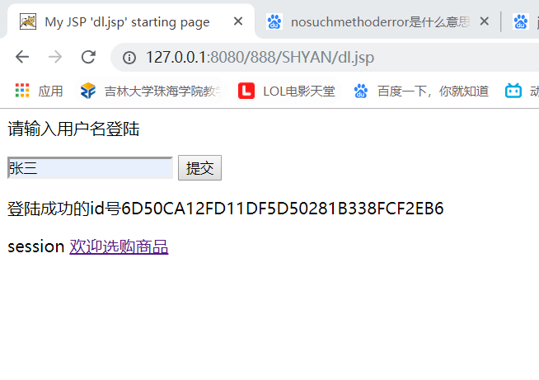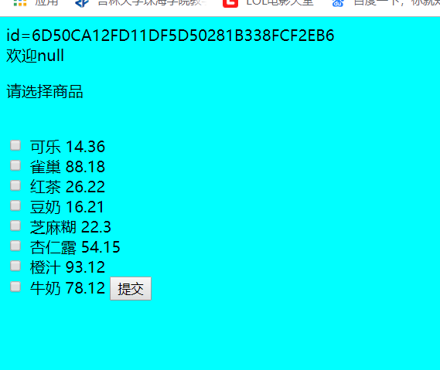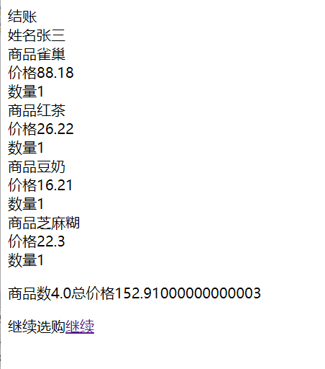

二．